Begin

Input math

Input physics

Input chemistry

Average = (Math + Physics + chemistry )/3

Display Average

End

Average = (Math + Physics + chemistry )/3

End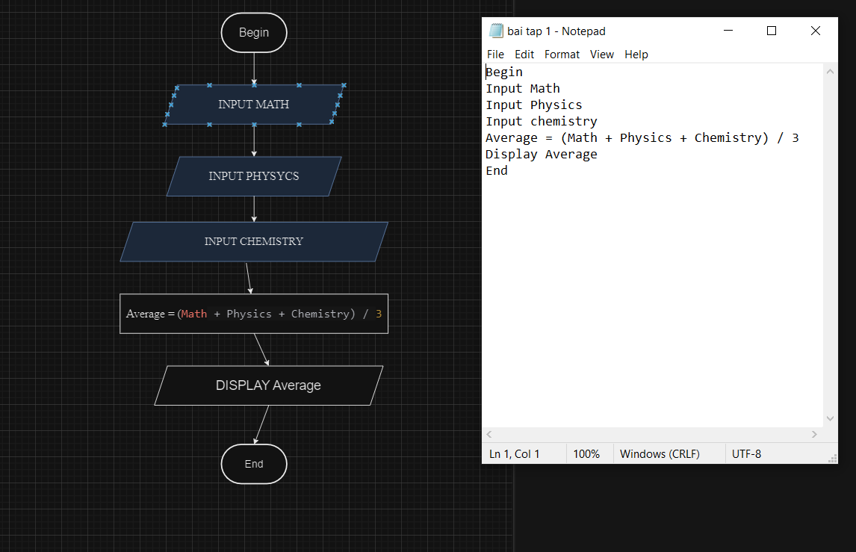

DISPLAY average

INPUS CHEMISTRY

INPUT PHYSICS

INPUT MATH

Bengin